**NOTE: |  | 1. Torque bolts as per the order designated on the drawing
 |  | 2. Sets are to be tensioned in the order of 50%, 75% then 100% of the torque requirement
 |  | 3. Calibration sheets for all tooling used in the tensioning process must be attached to this sheet
 |  | 4. Confirmation of torque setting from client attached
TORQUE SIGN- OFF |  |  |  |  | 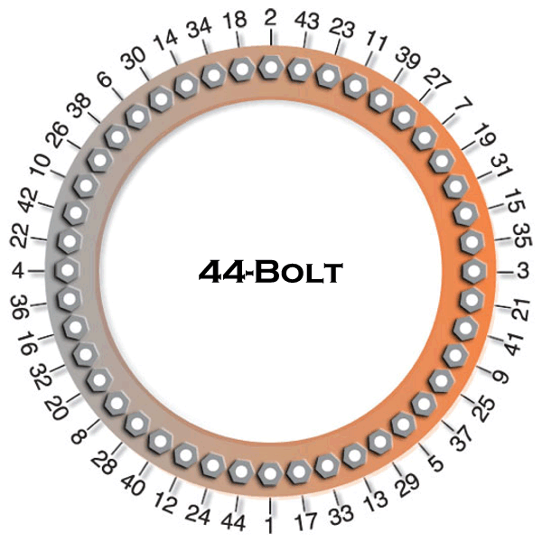
Bolt No | 50% |  | 75% | 100%
1 | ☐ |  | ☐
2 | ☐ |  | ☐
3 | ☐ |  | ☐
4 | ☐ |  | ☐
5 | ☐ |  | ☐
6 | ☐ |  | ☐
7 | ☐ |  | ☐
8 | ☐ |  | ☐
9 | ☐ |  | ☐
10 | ☐ |  | ☐
11 | ☐ |  | ☐
12 | ☐ |  | ☐
13 | ☐ |  | ☐ |  |  |  | Torque 100% | Nm | Bolt Size
14 | ☐ |  | ☐ |  |  |  | Torque 75% | Nm | Bolt Grade
15 | ☐ |  | ☐ |  |  |  | Torque 50% | Nm
16 | ☐ |  | ☐ |  |  |  | Bolt No | 50% | 75% | 100%
17 | ☐ |  | ☐ |  |  |  | 31 | ☐ | ☐
18 | ☐ |  | ☐ |  |  |  | 32 | ☐ | ☐
19 | ☐ |  | ☐ |  |  |  | 33 | ☐ | ☐
20 | ☐ |  | ☐ |  |  |  | 34 | ☐ | ☐
21 | ☐ |  | ☐ |  |  |  | 35 | ☐ | ☐
22 | ☐ |  | ☐ |  |  | 36 |  | ☐ | ☐
23 | ☐ |  | ☐ |  |  | 37 |  | ☐ | ☐
24 | ☐ |  | ☐ |  |  | 38 |  | ☐ | ☐
25 | ☐ |  | ☐ |  |  | 39 |  | ☐ | ☐
26 | ☐ |  | ☐ |  |  | 40 |  | ☐ | ☐
27 | ☐ |  | ☐ |  |  | 41 |  | ☐ | ☐
28 | ☐ |  | ☐ |  |  | 42 |  | ☐ | ☐
29 | ☐ |  | ☐ |  |  | 43 |  | ☐ | ☐
30 | ☐ |  | ☐ |  |  | 44 |  | ☐ | ☐
COMMENTS:

CIVMEC | Name | Signed | Date
CLIENT | Name | Signed | Date

