Tag No. «Name» - «Description»
Subsystem: «ProcessBreakdownIdentifier» - «ProcessBreakdownName»
Manufacturer. | «ManufacturerName» | Model No. | «OEMPartNumber»
Field to record Serial No. | «SerialNumber»
Drawing No. | «DocumentList» | Task No. |  | «TaskName»
Additional Information: | «Comments»

NOTE: | 1. Flange bolting requirements shall be as indicated in the piping materials specification.
NOTE: | 2. Flange tightening shall be carried out in accordance with an approved method or procedure, for example refer  to AS2129. Bolt torques for equipment, valves and lined piping shall be in accordance with the relevant standard  or supplier’s recommendations.
NOTE: | 3. Flanged connection shall be tightened sequentially diagonally opposite in clockwise or anticlockwise order so that an  even gasket seating results. Bolts are to be numbered in the field.
NOTE: | 4. Bolts are to be prepared as per manufactures recommendation.
NOTE: | 5. Sets are to be tensioned as per excerpt “Bolt torques as a percentage of final bolt torque” from SS-M198, below.
NOTE: | 6. At the end of the first sequence of hand tightening the joint shall be inspected to ensure that the flange  faces are parallel and no gap exists between the flange faces and the gasket.
NOTE: | 7. Pipe flanges connected to running equipment shall be parallel to within 1mm / 200mm measured across  any diameter. (as per AS3892 Section 6.3.2)
NOTE: | 8. All flanged joints shall be presented to the running equipment unbolted for feeler gauge inspection by the Rio Tinto  company representative before final bolting to prove their alignment.
NOTE: | 9. On all bolted and stud-bolted connections the bolts and nuts shall be coated in an approved anti seize compound.
NOTE: | 10. All bolted connections shall use bolting in accordance with the pipe specification data sheets.
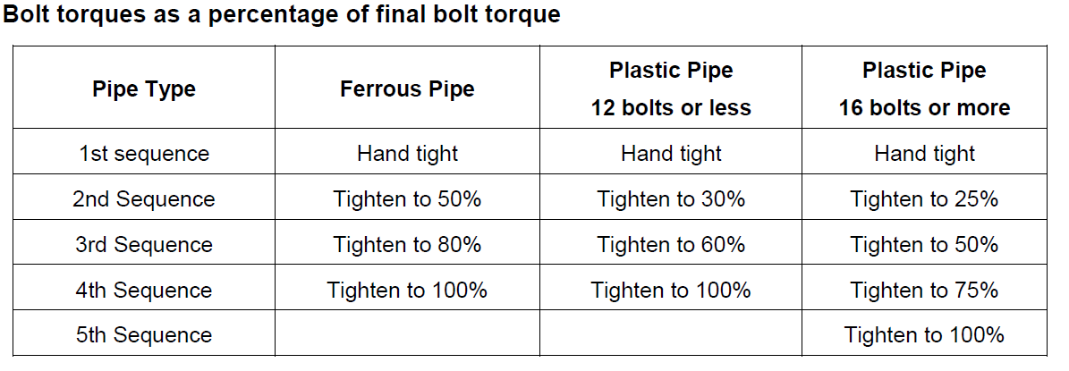
TEST EQUIPMENT
Test Equipment (Torque Wrench / Hytorc I.D Number) | Serial No. | Calibration Due Date

TORQUE SIGN-OFF |  |  |  |  |  |  |  |  | 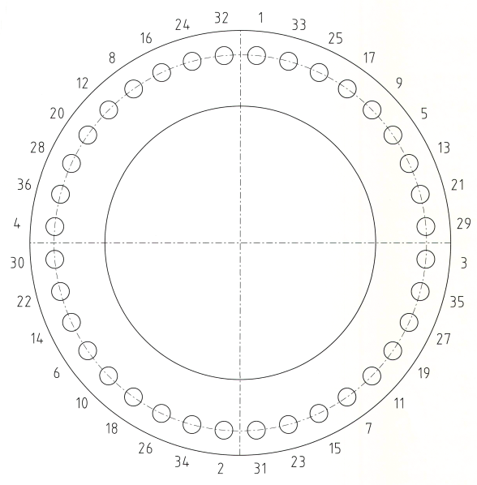
Bolt No. |  | _____% |  | ______% | ______% |  | ______%
1
2
3
4
5
6
7
8
9
10
11
12
13
14 |  |  |  |  |  |  |  |  | Data as per specification to be recorded below -
15 |  |  |  |  |  |  |  |  | Torque_______% | Nm |  | Bolt Size
16 |  |  |  |  |  |  |  |  | Torque_______% | Nm |  | Bolt Grade
17 |  |  |  |  |  |  |  |  | Torque_______% | Nm
18 |  |  |  |  |  |  |  |  | Torque_______% | Nm
19
20
21
22
23
24
25
26
27
28
29
30
31
32
33
34
35
36
COMMENTS, OBSERVATIONS & ATTACHMENTS
(Complete a Punchlist Form and attach if any of the checks above marked as “Punch”)
 | COMPLETED
 | I hereby confirm the work has been completed in accordance with Contract specified drawings, specifications & standards.
 | PERFORMED BY CONTRACTOR: |  |  |  |  | REVIEW BY SUPERVISOR/LEAD ENGINEER: |  |  |  |  | EPCM ACCEPTED BY:
 | Signature: |  |  |  |  | Signature: |  |  |  |  | Signature:
 | Name: |  |  |  |  | Name: |  |  |  |  | Name:
 | Title: |  |  |  |  | Title: |  |  |  |  | Title:
 | Date: |  |  |  |  | Date: |  |  |  |  | Date:

